Pastoral Information packet

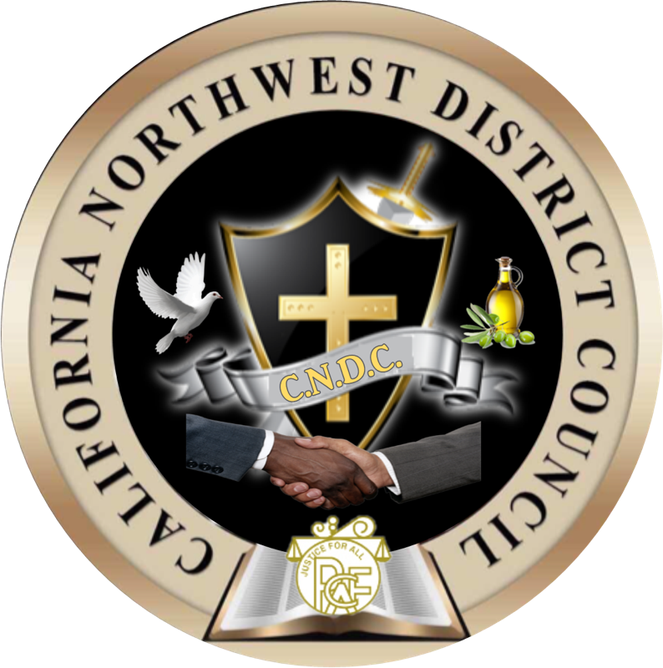

Pentecostal Churches of the Apostolic faith international

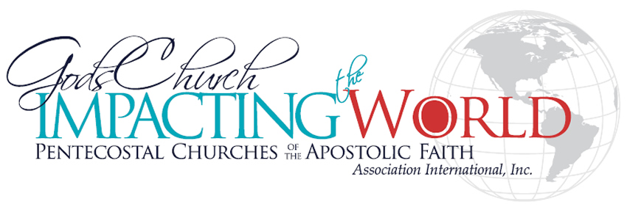
The California-Northwest District Council
2nd Episcopal District of the PCAF Inc. International
Bishop Lewis D. Stallworth Jr.
Diocesan Bishop

Greetings in the matchless and magnificent name of Jesus!

The California-Northwest District Council is a Covenant Fellowship of Pastors and Churches who desire to achieve ministerial excellence, assist in developing churches, and serve as refuge for independent churches and ministries. This can be accomplished through training, mentoring and needed resources that enhance leaders and their churches spiritually, holistically and financially. The CNDC was developed to be a network and fellowship for Pastors and churches within the California and Pacific Northwest Region.
The CNDC is a Christian fellowship of churches and sub-division of the Pentecostal Churches of the Apostolic Faith, Inc. We are a continuation of the Apostles doctrine in word and deed. It is our desire to build and promote a progressive and innovative Christian fellowship for the 21st century. Within our council, we desire to create an environment where every pastor and leader can be provided with the necessary tools to mature and strengthen their individual call and God given vision as understood by each member church. Through unity and the networking of our collected member resources, all of our fellowshipping churches can and will benefit.

The Mission of the CNDC is to create a fellowship of Churches, providing a positive environment for Pastoral growth, leadership training & development, ministerial mentorship and Christian Education for the purpose of promoting Christ-Centered programs and strengthening the faith of believers till the day of the Lord’s return. Iron sharpeneth iron; so a man sharpeneth the countenance of his friend (KJV Prov. 27:17).

The California-Northwest District Council recognizes the need for networking, accountability, fellowship and resource facilitation. Our key concern is that all of our churches be provided tools to mature the individual call and the vision of God as understood by each church affiliate. Through networking and collaboration our council will assist all of our churches and ministries in fulfilling their respective roles in the Body of Christ.

The purpose of the California-Northwest District Council is to:

- To provide a spiritual covering and oversight for pastors, churches and independent ministries.
- To be a network support system, providing a consistent flow of ministry resources and communication for affiliated members through conferences and workshops.
- To be a ministerial training center for Pastors, leaders, administrators and laity. Providing biblical insight for ethics and morality in ministry.
- To offer recognition in various levels of gifts and callings, and providing ministerial license and ordination credentials as appropriate.

Faith Statement: We believe these fundamental and foundational principals to be the grounds by which we have fellowship one with another.

OUR DOCTRINAL BELIEF
The Pastor(s), Churches and ministries of the PCAF and all of states council’s all believe in the Oneness of the Godhead, according to St. John 1:1-3, vs.14, I Timothy 3:16, that Jesus was both God and man - “without controversy God was manifested in the flesh.”
- We also believe in the virgin birth of Jesus according to Matthew 1:21-25 ...and His name shall be called Jesus.
- We believe on Acts 2:38 Repentance and baptism (emerged) in the name of the Lord Jesus Christ for remission of sins and the infilling of the Holy Ghost, Colossians 3:17 Acts 4:12…There is none other name under heaven given among men, whereby we must be saved. This is the plan of salvation.
- We believe at the conception of the “New Birth” that speaking in tongues as the Spirit of God gives utterance is evidence that His Spirit has come to dwell within. Acts 2:3-4
- We believe I Corinthians 1:2 we are an Ecclesiastical body called “Saints” a holy people, a royal priesthood set apart unto sanctification from the world to propagate the True Word of God that others might believe and react in accordance; to reveal the Oneness of His Deity & live before men a holy and clean life through the word and the power of God, continuously being illuminated out of love and faith towards Him.
- We believe in the pre-tribulation Rapturing (caught up/out) of the church/The Bride of Christ. I Thessalonians 4:13-17
- We believe in the Judgment Seat of Christ is for the church. All whom shall attend are saved eternally even though…some may suffer loss in regard to their works. I Corinthians 3:3-15
- We believe in the Millennium (1,000 years), where Christ and His Bride shall reign and rule.
- We believe that Death and Hell shall be cast into the Lake of Fire, which is God’s eternal judgment and damnation upon those who believe not on His name and reject the truth.
- We believe in the “New Heaven” and “New Earth” to come

FIVE-FOLD MISSION AND AIM
1. ASSOCIATION
As we find a connection through the sharing of ideas we find it necessary to enter into covenant partnership. As covenant partners we are--on the same team--but, we maintain our own distinct identity and individuality in Christ. The CNDC does not seek to be an instrument of ecclesiastical restraint or control in the sense of diminishing your churches identity or ministry's individual calling. Our aim is to promote fellowship and interdependence among our bretheren.
"Simon Peter, a servant and an apostle of Jesus Christ, to them that have obtained LIKE PRECIOUS FAITH with us..." II Peter 1:1
2. FELLOWSHIP
Within Fellowship, we find great strength in the diversity of our backgrounds and experiences throughout the Body of Christ. Therefore, it is not our desire to become uniform in method, operation nor function. It is through fellowship that we take full advantage of the collective wisdom, knowledge and judgment that comes from God. We promote companionship and mutual sharing of interests, visions, ideas and information. Our aim is unity without uniformity.
"Behold, how good and how pleasant it is for brethren to dwell together in unity!" Psalm 133:1
3. RELATIONSHIP
Establishing and maintaining strong relationships is vital to the success of this Council. As we make every effort to strengthen one another, we certainly recognize the importance of knowing one another, respecting one another and esteeming each member highly. The CNDC offers a system of accountability which adheres to Biblical principles and insists upon the highest level of integrity and responsibility in ministry. Our aim is accountability and leadership within our Jurisdiction.
"Therefore encourage one another and build up one another, just as you also are doing. But we request (beseech or ask), brethren that you appreciate (know) those who labor among you..." and to esteem them very highly in love for their work's sake. And be at peace among yourselves." I Thessalonians 5:11-13
4. INFORMATION
The sharing of vital information and words of encouragement causes the participants of an organization or group to feel connected and to have mutual understanding. Regular and consistent communication by the written word was practiced in the early church. The Apostle Paul gave this charge to the church at Thessalonica: "I adjure (charge) you by the Lord to have this letter read to all the brethren (churches)." I Thessalonians 5:27.

The CNDC Network will communicate with member churches and ministries on a monthly basis via audiotape, videotape or newsletter. The CNDC will utilize all of today’s technology also a means of communication for participating members.

Our aim is to edify and inform members of pertinent information that pertains to the fellowship. "….my people are destroyed for lack of knowledge (range of information and understanding)..."Hosea 4:6
5. COUNSEL
As men and women of God work to uphold and advance the kingdom of God they will face, on a daily basis, the onslaught of the forces of darkness. We must take advantage of the spiritual insight and Godly counsel we possess collectively in order to withstand the constant barrage. The CNDC intends to help meet the needs of its member churches and ministries while allowing them to maintain full autonomy. Our aim is to give insight as well as oversight.
"For by wise guidance (counsel) you will wage war, and in abundance (multitude) of counselors there is victory (safety or safe keeping)." Proverbs 24:6

The MEMBERSHIP into the CNDC is based on a two-step process and alignment.

The (1) step is a FELLOWSHIP status

- FELLOWSHIP STATUS.
As a Fellowship Member:
- The local church or group of churches is asked to attend, participate, AND support the CNDC Fellowships and all gatherings in attendance, financially support and to attend all leadership gatherings and regional meetings (if at all possible), by our Diocesan Bishop.
- The Pastor of the local church or churches is asked to attend the Regional, State and/or Call meetings as hosted (if at all possible) by the Diocesan Bishop and/or headquarters church.
- Once the local Pastor is moved from Fellowship status, to an Affiliated Status, that Pastor may be able to hold an elected office within the District. (Offices shall be defined.)
- The property of any fellowshipping church will not be involved at all in any negations or business deals as a pre-requisite to membership.
- The affiliated church shall embrace the beliefs, creeds and convictions of the Apostles doctrine and Pentecostal Churches of the Apostolic Faith, Intl.

The local church or group of churches is to meet all claims and assessments and embrace the organization’s doctrine. Additionally, the local church or group of churches is asked to but not required to carry the “brand” (i.e. logo or identifying mark etc.) of the CNDC Whether on stationary and correspondence, website, and/or within the church facility in order to show that they are in fellowship and unified with the CNDC/PCAF Organization.

The (2) step is the ORGINIZATIONAL MEMBERSHIP & AFFILITION.

II. PCAF Affiliation Requirements.
As a PCAF Affiliated Member: You become a subsidiary or branch of this existing organizational fellowship within your local Jurisdiction. As an affiliate member of the PCAFI you and your church members become connected to other local area PCAFI ministries with the International organization and all of its Districts.
A. The local church or group of churches in affiliation shall be required to support and be represented at all call meetings, Regional/State councils and National Meetings or Convocations. (If at all possible).

B. All Local churches who are AFFILIATED members will be required to support our organizations 5% financial church assessment program submitted to the International PCAFI Treasury. Your churches 5% assessment is made up from your weekly church offerings or donations given to the ministry. By supporting the National Church, we are assured that all of our National and International affiliate Churches and vision of our National Church is supported.

C. Local churches are asked to attend, participate and fellowship with your local, State and the International Holy Convocation.

The Pentecostal Churches of the Apostolic Faith International Inc.

It is not the desires of this fellowship to coheres or lead any church pastor or ministry away from their existing church Organization. However, it is our desire to expand the work of Lord, be about our father’s business and create an environment conducive for kingdom growth. Our mission is to become a catalytic and resource agent for the unity and support of churches and ministries who desire to fulfill destiny.

Enclosed you will find a letter of intent and P.C.A.F.I application.

If you fill that the California-Northwest District Council and P.C.A.F.I Inc. could benefit you and your church/ministry, we would like you to contact me at:

Greater Christ Temple of Stockton, Inc.
8800 Thornton Rd, Stockton Ca 95219

Attn: Bishop T. David Dockery Sr.
Dir. Of Operations/Church Recruitment

CC:Bishop Lewis D Stallworth Jr. Council Bishop

By signing this letter, we endorse the above regulations and indicate our intent to unite with the California-Northwest District Council of the P.C.A.F.I. Inc.

I/We affirm that I/We have read and understood the aforementioned information and express our interest and intent to become an:  FELLOWSHIP MEMBER/ OR AFFILIATED MEMBER OF THE California and Western States Council/and the PCAF.

Pastor or Overseers Name/Officer of Organization

Name of Church or Ministry Affiliation
Phone ( )______________________
Street address

City State Zip code

Are you currently a licensed or ordained as a minister within a recognized religious fellowship or Denomination?

If Yes, what is the name of the fellowship? _____________________________ No____.

Who is your Presiding Bishop or Overseer? ________________________________.

If you are a pastor, is your church an independent organization or part of a larger body? .

By signing this document, I agree that I have read and understand the terms outlined herein, and that I am completely aware of what I am agreeing to:

Print Name: ____________________________ Date: ___________.

Sign Name: _____________________________Date: ___________.

